**Street Sweepers**

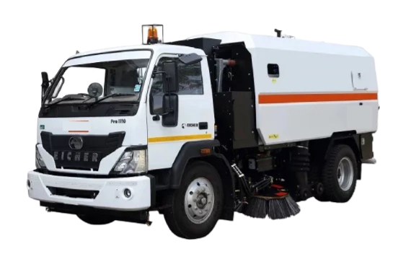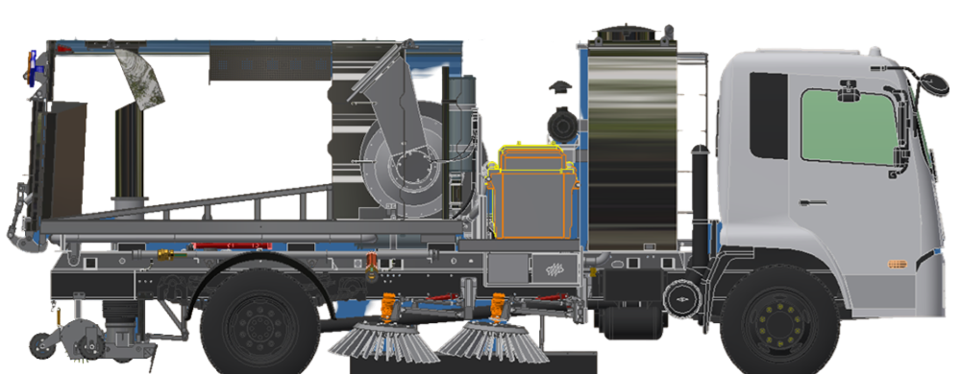

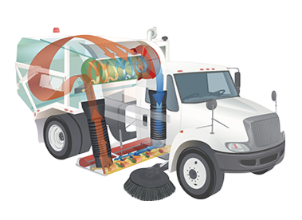

Chassis-mounted Pure Vacuum, mechanical and regenerative air sweeper with different capacities.

The basic design of regenerative the street sweeper has had many years of successful operation throughout the United States and around the world.

Because of its relatively compact size, the street sweeper requires no Commercial Driver's License for operation and offers great manoeuvrability.

With its sweeping power and environmentally-friendly regenerative air design, it is an ideal choice for use in a wide range of demanding road sweeping applications.  
The sweeper's blower system generates a high velocity air column which is propelled into the top of its sweeping head through a blast tube. The air is first pressurized in the upper chamber of the sweeping head, then expelled into the head's lower chamber through what is called a "blast orifice".

This is a slot in the sweeping head that forces the air against the pavement at an angle, creating a "peeling" or "knifing" effect.

The high-volume air blast loosens the debris from the pavement surface, then transports it across the width of the sweeping head and lifts it into the containment hopper via a suction tube.   
This is a highly efficient system which ensures that even hard-to-reach particles hidden within pavement cracks and irregularities are removed, including the "PM-10 fines" known to contain a high percentage of heavy metals, phosphates and other pollutants.   
Double-belted curtains on the front and rear of the sweeping head contain the circulating air flow to assure debris transfer with minimal fugitive dust particles.

In contrast to mechanical broom sweepers, the sweeper collects and retains the micron-sized contaminants that accumulate on roads and streets. Recent studies emphasize the importance of removing these "PM-10 fines" due to the non-point source pollutants that contribute to the stormwater runoff stream. Using the regenerative air sweeper results in a cleaner street and a cleaner environment

**Chassis:**  
A selected truck chassis is provided to give adequate ratings of all components compatible with hopper capacity. Consult for detailed requirements.

**Optional Equipment:**  
Dual steering, cab-mounted bar light beacon, arrow board, washdown system, special lighting, ether cold starting aid, engine block heater, load weight indicator, automatic lube system, and others. Consult the factory for a listing of all currently available options